Chapter 1 - Introduction and case study
In many educational institutions today, the heavy reliance on fragmented manual paperwork and legacy record-keeping creates severe administrative bottlenecks, making it arduous to track student registrations, manage course catalogs, record exam scores, and provide learners with transparent access to their academic progress. Without an integrated digital solution, administrative staff suffer from disorganized data and overwhelming workloads, while students are left in the dark regarding their grades and profile updates.

To solve this, our Student Management System introduces a centralized digital ecosystem designed around three distinct actors: Students, who want seamless, real-time access to view their profiles, track course enrollments, and monitor their exam scores; Administrators, who need efficient tools to register new students, manage course offerings, record marks, and generate printable institutional reports; and Super Admins, who require top-level authority to oversee system operations, create new administrator accounts, and control system-wide permissions.

At the core of this environment exist four primary entities: Students, who are uniquely identified by their username and credentials while holding detailed personal attributes such as first and last name, phone number, date of birth, address, gender, and profile photo; Courses, which are characterized by attributes including course name, duration, and total credit hours; Scores, which capture the specific performance marks obtained by a student in an enrolled course; and Admins, whose profiles are defined by administrative credentials, contact details, and an active or inactive status flag.

These entities interact through well-defined relational pathways: a student can register and enroll in multiple courses, a single course can host numerous students, and individual score records link specific students to their respective course achievements, while the Super Admin maintains hierarchical governance over all Admin accounts. Financially, the system accommodates institutional revenue flow by tracking course registration and tuition fees paid by students and processed through administrative oversight, ensuring clear financial tracking for the institution without involving external third-party platform commissions.

Chapter 2 – Functional Requirements & User Stories

(a) Functional Requirement List
Admin & Super Admin
- Admin can register new students by capturing personal, contact, and profile image data.
- Admin can view, search, update, and delete student records.
- Admin can generate and print reports containing student information.
- Admin can enroll students into specific courses.
- Admin can create new courses with duration and hourly details.
- Admin can manage existing courses through search, update, and delete operations.
- Admin can generate and print course reports.
- Admin can record individual student scores for specific courses.
- Admin can manage score records via search, update, and delete operations.
- Admin can generate and print result reports for individual students or courses.
Super Admin Only 11. Super Admin can create new Admin accounts with secure credentials and status toggles. 12. Super Admin can manage (view, search, update, delete, activate/deactivate) existing Admin accounts. 13. Super Admin can generate and print Admin account reports.
Student 14. Student can view their own profile information. 15. Student can update their personal profile details. 16. Student can view their course scores and academic results. 17. Student can print their profile and score summaries.

(b) User Stories
As an Admin/Super Admin, I can register a new student, so that they can be tracked in the system. Details: The Admin clicks "Student Registration" to open a form containing fields for First Name, Last Name, username, password, phone, DOB, address, gender, and photo upload. The system validates that all fields are filled and the username is unique before saving. On click of the "Save" button, a new record is inserted into the Students table, and the form resets.
As an Admin/Super Admin, I can manage student records, so that data remains accurate and up-to-date. Details: The Admin navigates to "Manage Student" and uses a search bar to filter students by name or ID. A list is displayed in a DataGridView, where the Admin can select a row to either "Update" or "Delete" the information. Once an action is confirmed, the database updates or removes the record, and the UI refreshes to show the current state.
As an Admin/Super Admin, I can enroll a student in a course, so that their academic path is defined. Details: The Admin selects a student and a course from respective dropdown menus under the "Enroll To Course" section. The system checks if the student is already enrolled in that course to prevent duplicates. Upon clicking "Enroll," the relationship is stored in the Enrollment table, linking the StudentID and CourseID.
As an Admin/Super Admin, I can add a new course, so that the institution can offer new subjects. Details: The Admin opens the "Add Course" form which requires Course Name, Course Duration, and Course Hours. The system validates that Duration and Hours are positive integers. Upon submission, a new entry is added to the Courses table, making the course available for student enrollment.
As an Admin/Super Admin, I can record a student's score, so that their performance is documented. Details: The Admin selects the target student and the relevant course from dropdown lists, then enters the numeric marks in the "New Score" section. The system validates that the marks are within a valid range (0-100). When "Save" is clicked, the score is saved in the Scores table, associating the student, course, and grade.
As a Super Admin, I can add a new Admin, so that administrative duties can be delegated. Details: The Super Admin fills out a form requiring First Name, Last Name, Username, Password, Phone, Email, Address, and an Active/Inactive status. The system validates that the username and email are not already in use. Upon clicking "Create," a new user record is inserted into the Admin/Super Admin table with the assigned status.
As a Student, I can view my profile, so that I can verify my personal information. Details: Upon logging in, the Student navigates to the "See Profile" section. The system retrieves the student's data from the database based on their logged-in UserID and displays it in a read-only layout. This provides the student with an instant overview of their registered details.
As a Student, I can update my profile, so that my contact information remains current. Details: The Student clicks "Update Profile," which populates editable fields with their existing data. The student can modify fields such as Phone, Address, or Password. Upon clicking "Save," the system validates the new input, updates the database record, and displays a success confirmation.
As a Student, I can watch my scores, so that I can track my academic progress. Details: The Student navigates to "Watch Score" to view a list of all their enrolled courses and associated grades. The system pulls data from the Scores and Enrollment tables based on the StudentID. The results are displayed in a formatted table or list for easy readability.
As a Student, I can print my records, so that I have a physical copy of my results. Details: The Student selects "Print" from the dashboard, which opens a print preview window generated from the system data. This allows the student to send their academic summary or profile details to a local printer. The printout is formatted professionally for clarity.

Chapter 3 – UI Navigation Diagram
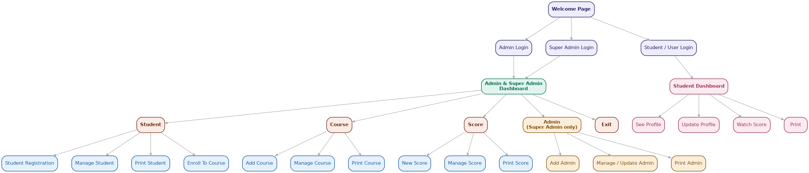

Chapter4 – Database Design
*SQL Schema Diagram
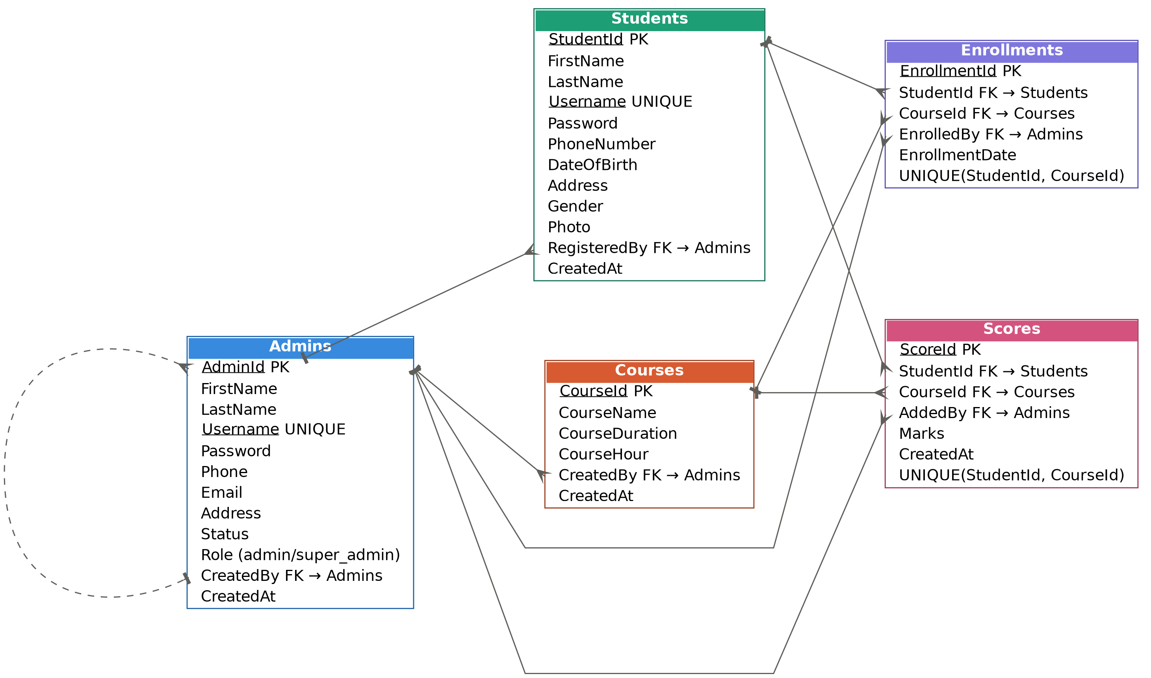

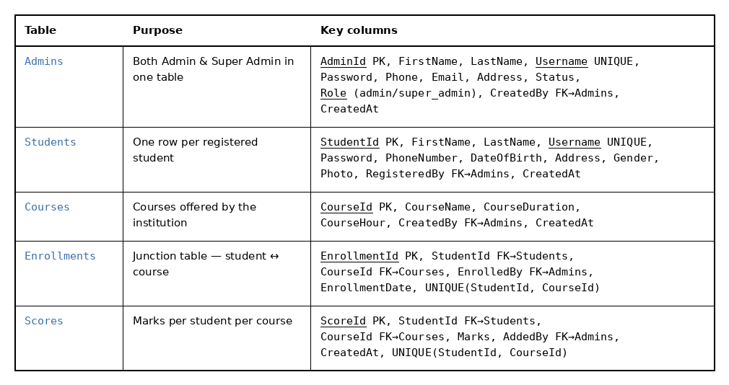

*ER Diagram
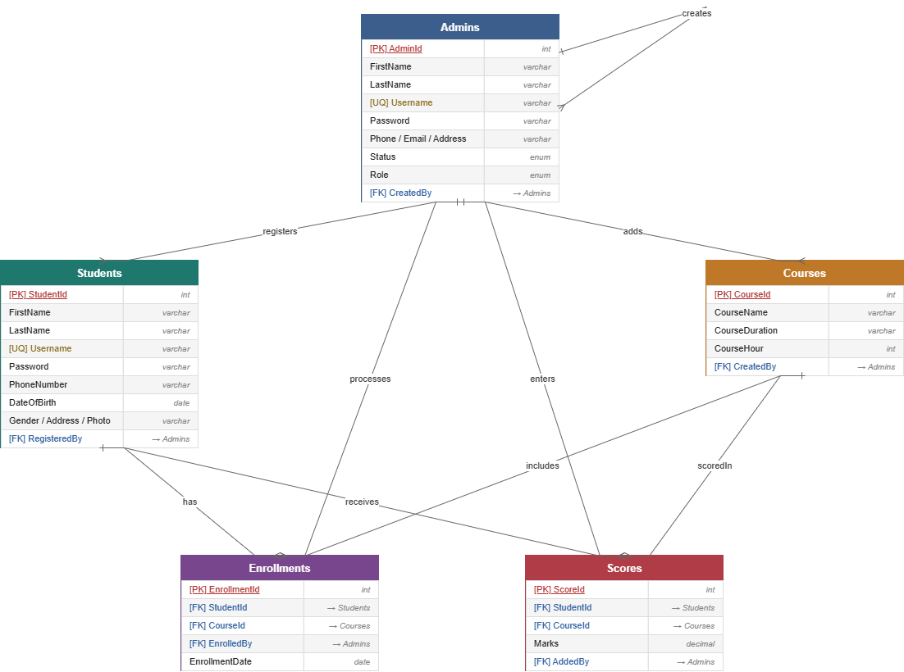
*Normalization – 3NF

1NF - Atomic values, no repeating groups
Rule: every column holds a single, indivisible value; no repeating groups or arrays in a cell.
Checking each table:
- Admins - every field (Name, Username, Password, Phone, Email, Address, Role) is atomic. OK
- Students - same, one value per cell (Photo is a single file reference, not a list). OK
- Courses - CourseName, CourseDuration, CourseHour are all single values. OK
- Enrollments and Scores - each row is one student-course pairing, not a list of courses per student. OK
Would violate 1NF: if Students had a column like Courses equals "Math, Physics, Chemistry", a comma separated list in one cell. Your design avoids this by using the separate Enrollments junction table instead. That is exactly the correct 1NF fix.
Verdict: your schema satisfies 1NF as is.

2NF - 1NF plus no partial dependency on a composite key
Rule: applies only to tables with a composite primary key. Every non-key column must depend on the whole key, not just part of it.
Checking each table:
- Admins, Students, Courses - each has a single column PK (AdminId, StudentId, CourseId). Single column PKs cannot have partial dependencies, so 2NF is automatically satisfied. OK
- Enrollments - PK is EnrollmentId, a surrogate key, not the composite of StudentId and CourseId. Since the actual PK is single column, there is no partial dependency to worry about. EnrollmentDate depends on the enrollment as a whole. OK
- Scores - same pattern: ScoreId is the real PK, StudentId plus CourseId is just a UNIQUE constraint, not the key. Marks depends on ScoreId as a whole. OK
Would violate 2NF: if you had made StudentId and CourseId together the actual primary key of Enrollments, and then added a column like StudentName, that would depend only on StudentId, part of the key, not the full composite. Using surrogate keys (EnrollmentId, ScoreId) avoids this problem entirely, which is why your design is clean.
Verdict: satisfied, helped by your choice of surrogate PKs on the junction tables.

3NF - 2NF plus no transitive dependency on non-key columns
Rule: non-key columns must depend on the key, the whole key, and nothing but the key. No non-key column should determine another non-key column.
Checking each table:
- Admins - Role, Status, Email, etc. all depend directly on AdminId. No column depends on another non-key column. OK
- Students - same check: Gender, Address, DateOfBirth all depend directly on StudentId, not on each other. OK
- Courses - CourseDuration and CourseHour both describe the course directly, via CourseId, not derived from one another. OK
- Enrollments - EnrollmentDate depends on EnrollmentId directly. StudentId and CourseId are FKs, not derived data. OK
- Scores - Marks depends on ScoreId directly, not on StudentId or CourseId alone. OK
Would violate 3NF: a common real world mistake here would be storing something like AdminName inside the Students table, copied from Admins via RegisteredBy. That is a transitive dependency, StudentId determines RegisteredBy determines AdminName, and it also risks data going stale if the admin's name changes. Your design correctly keeps that data only in Admins and reaches it via FK.

Chapter 5 – SQL Queries

Admins

INSERT INTO Admins (FirstName, LastName, Username, Password, Phone, Email, Address, Status, Role, CreatedBy, CreatedAt)
VALUES ('John', 'Doe', 'johndoe', 'hashedpassword', '01700000000', 'john@example.com', 'Dhaka', 'active', 'admin', 1, NOW());

SELECT * FROM Admins;

SELECT * FROM Admins WHERE AdminId = 1;

SELECT * FROM Admins WHERE Role = 'super_admin';

SELECT * FROM Admins WHERE Status = 'active';

UPDATE Admins SET Phone = '01812345678', Status = 'inactive' WHERE AdminId = 1;

DELETE FROM Admins WHERE AdminId = 1;

SELECT Role, COUNT(*) AS TotalAdmins FROM Admins GROUP BY Role;

Students
INSERT INTO Students (FirstName, LastName, Username, Password, PhoneNumber, DateOfBirth, Address, Gender, Photo, RegisteredBy, CreatedAt)
VALUES ('Alice', 'Khan', 'alicek', 'hashedpassword', '01911111111', '2005-05-10', 'Dhaka', 'Female', 'alice.jpg', 1, NOW());

SELECT * FROM Students;

SELECT * FROM Students WHERE StudentId = 1;

SELECT * FROM Students WHERE RegisteredBy = 1;

SELECT * FROM Students WHERE FirstName LIKE 'Al%';

UPDATE Students SET Address = 'Chattogram', PhoneNumber = '01955555555' WHERE StudentId = 1;

DELETE FROM Students WHERE StudentId = 1;

SELECT Gender, COUNT(*) AS TotalStudents FROM Students GROUP BY Gender;

Courses

INSERT INTO Courses (CourseName, CourseDuration, CourseHour, CreatedBy, CreatedAt)
VALUES ('Web Development', '3 months', '60 hours', 1, NOW());

SELECT * FROM Courses;

SELECT * FROM Courses WHERE CourseId = 1;

SELECT * FROM Courses WHERE CreatedBy = 1;

SELECT * FROM Courses WHERE CourseName LIKE '%Development%';

UPDATE Courses SET CourseDuration = '4 months', CourseHour = '80 hours' WHERE CourseId = 1;

DELETE FROM Courses WHERE CourseId = 1;

SELECT COUNT(*) AS TotalCourses FROM Courses;

Enrollment
INSERT INTO Enrollments (StudentId, CourseId, EnrolledBy, EnrollmentDate)
VALUES (1, 1, 1, NOW());

SELECT * FROM Enrollments;

SELECT * FROM Enrollments WHERE EnrollmentId = 1;

SELECT e.EnrollmentId, c.CourseName, e.EnrollmentDate
FROM Enrollments e
JOIN Courses c ON e.CourseId = c.CourseId
WHERE e.StudentId = 1;

SELECT e.EnrollmentId, s.FirstName, s.LastName, e.EnrollmentDate
FROM Enrollments e
JOIN Students s ON e.StudentId = s.StudentId
WHERE e.CourseId = 1;

SELECT * FROM Enrollments WHERE StudentId = 1 AND CourseId = 1;

UPDATE Enrollments SET EnrollmentDate = NOW() WHERE EnrollmentId = 1;

DELETE FROM Enrollments WHERE EnrollmentId = 1;

SELECT CourseId, COUNT(*) AS TotalEnrolled FROM Enrollments GROUP BY CourseId;

Scores

INSERT INTO Scores (StudentId, CourseId, Marks, AddedBy, CreatedAt)
VALUES (1, 1, 85.5, 1, NOW());

SELECT * FROM Scores;

SELECT * FROM Scores WHERE ScoreId = 1;

SELECT s.ScoreId, c.CourseName, s.Marks
FROM Scores s
JOIN Courses c ON s.CourseId = c.CourseId
WHERE s.StudentId = 1;

SELECT sc.ScoreId, st.FirstName, st.LastName, sc.Marks
FROM Scores sc
JOIN Students st ON sc.StudentId = st.StudentId
WHERE sc.CourseId = 1;

SELECT st.FirstName, st.LastName, sc.Marks
FROM Scores sc
JOIN Students st ON sc.StudentId = st.StudentId
WHERE sc.CourseId = 1
ORDER BY sc.Marks DESC
LIMIT 1;

UPDATE Scores SET Marks = 90.0 WHERE ScoreId = 1;

DELETE FROM Scores WHERE ScoreId = 1;

SELECT CourseId, AVG(Marks) AS AverageMarks FROM Scores GROUP BY CourseId;

Chapter 6 – UI Interface Design

*Welcome view


*Login
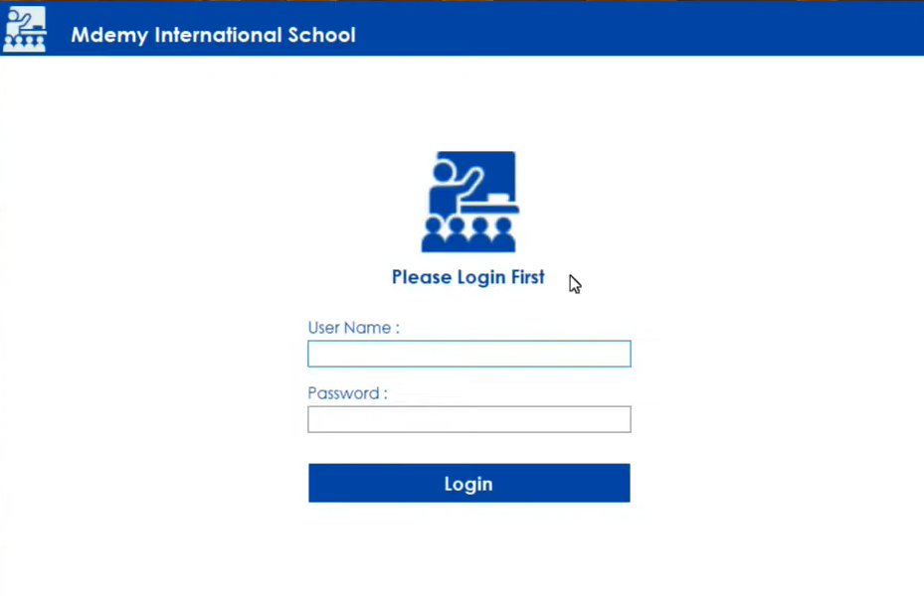

3.Dashboard
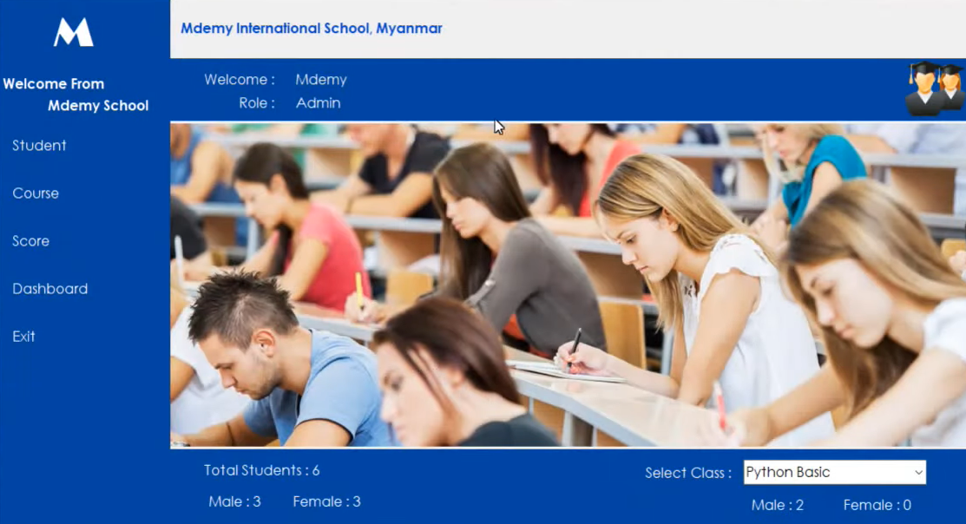
4.Registration
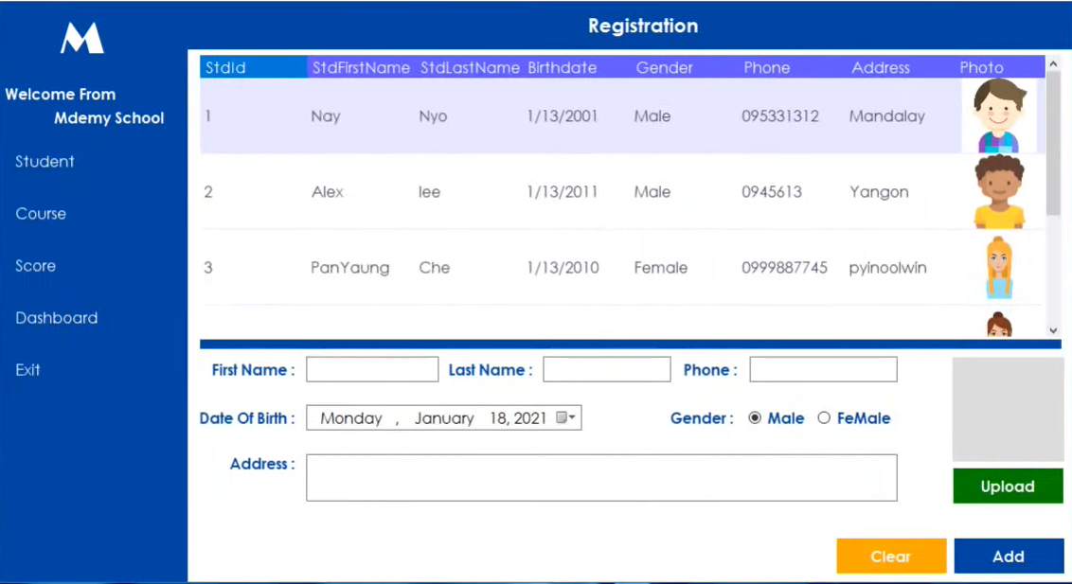

5.Manage Student
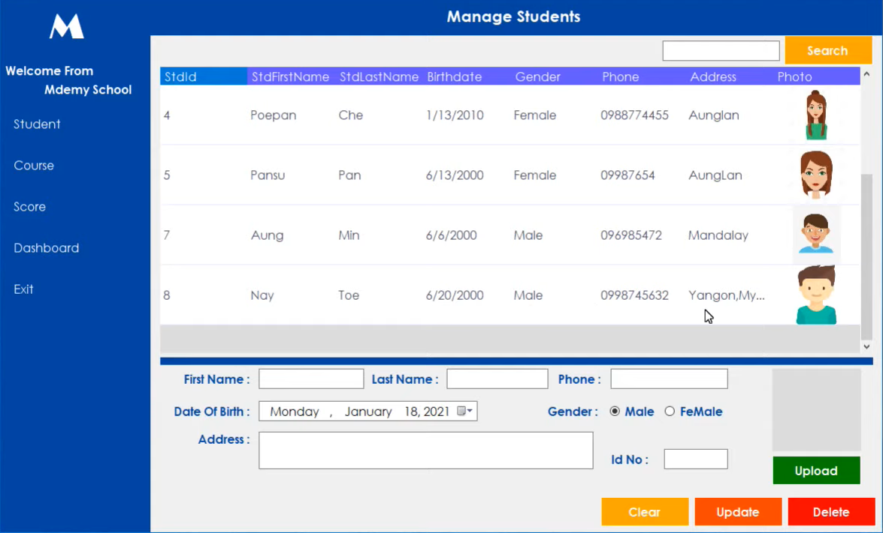
6.Print Student
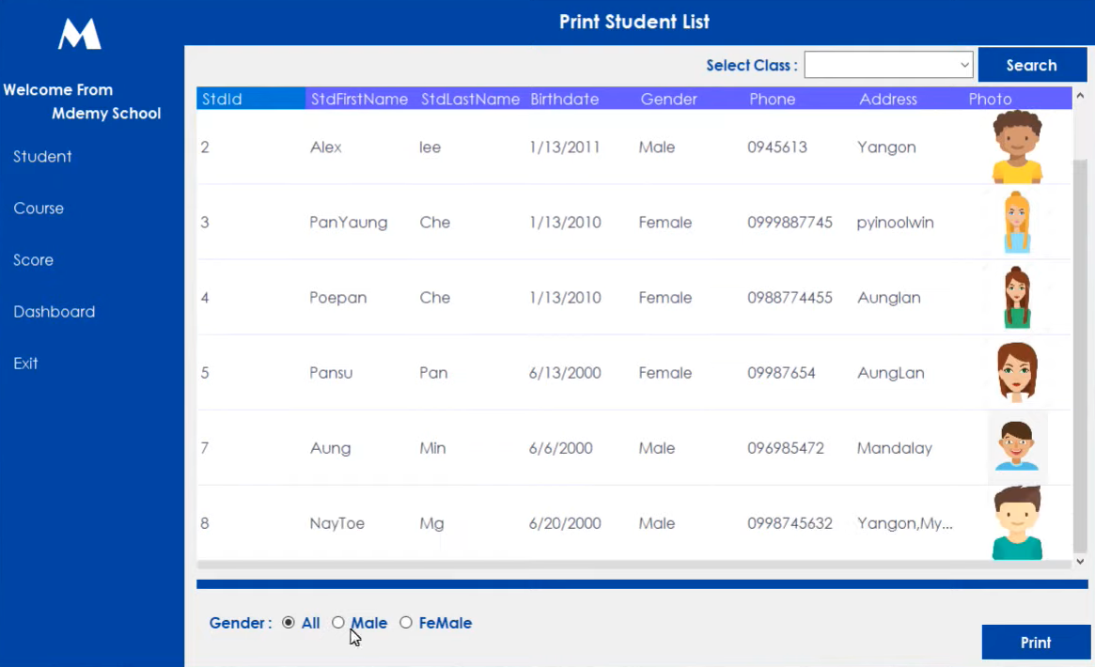
7.Add Course
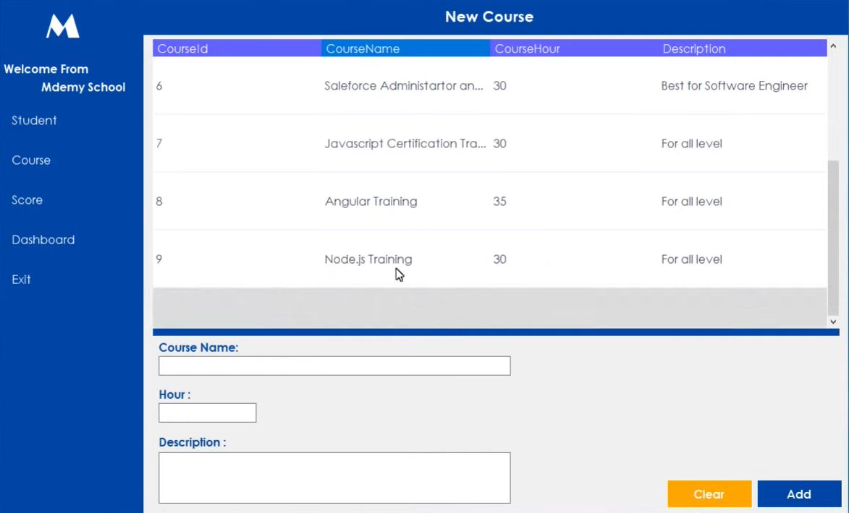
8.Mange Course
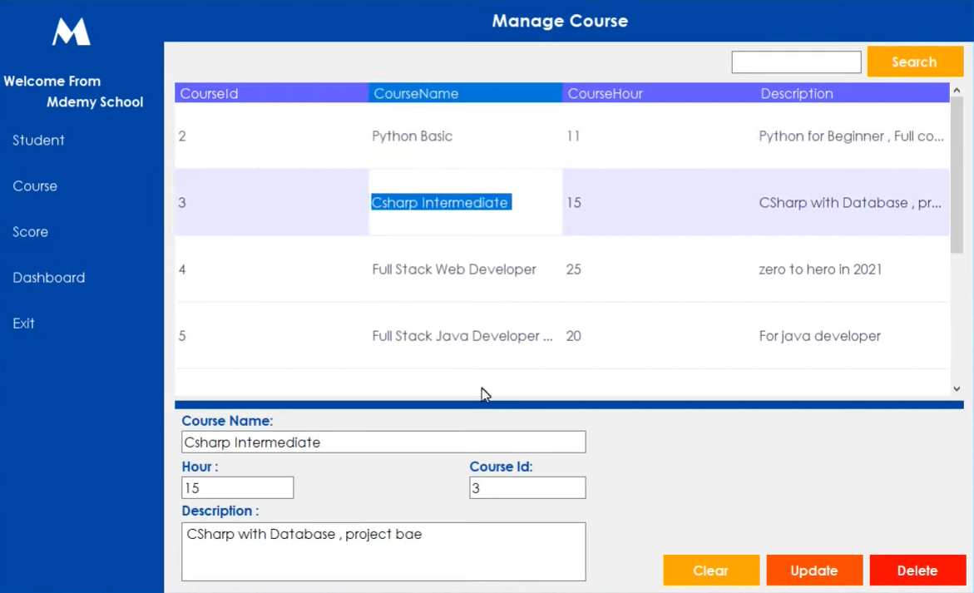
9.Print Course
10.Add Score
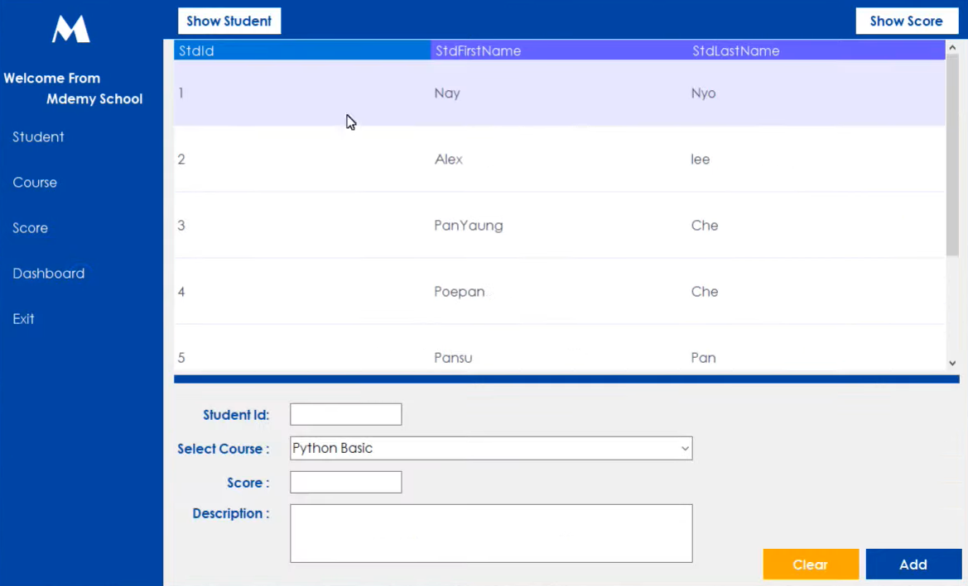
11.Manage Score
12.Print Score
Chapter 7 – Work Distribution
Name | Id | Exact Contribution
Shahriar Nafiz Nahin | 24-59162-3 | Case Study & Database Design
Badhon Kabiraj | 24-58369-2 | Functional Requirements, User Stories, & Admin/Student Modules
Nabila Islam | 24-57371-2 | Course & Enrollment Management
ARIFA ASHRAFY | 24-57193-2 | Score Management & Final Integration

Chapter 8 – Conclusion & Future Work
The development of the Student Management System marks a significant milestone in modernizing academic administration by replacing error-prone manual paperwork and fragmented legacy record-keeping with a secure, centralized digital platform. Throughout this project, we successfully established a robust architecture that streamlines institutional workflows across three distinct user roles: Students, Administrators, and Super Administrators. By implementing a structured relational database adhering to Third Normal Form (3NF), the system ensures complete data integrity, eliminating redundancies while efficiently managing vital entities such as student profiles, course catalogs, academic scores, and administrative credentials.
The integration of comprehensive functional modules empowers administrators to effortlessly register learners, assign course enrollments, record precise evaluation marks, and generate essential printable reports. Simultaneously, the dedicated student portal grants learners real-time, transparent access to their personal profiles, enrolled subjects, and academic performance summaries, fostering a more engaging and accountable educational environment. Furthermore, the incorporation of hierarchical governance through the Super Admin panel ensures that system permissions and account security are maintained with the highest standards of reliability.
Ultimately, this project bridges the operational gap between institutional staff and students, drastically reducing administrative overhead and data disorganization. The successful execution of normalized database schemas, optimized SQL querying, and intuitive user interface designs proves the system's scalability and readiness for real-world deployment. As educational institutions continue to embrace digital transformation, this Student Management System stands as a solid, efficient, and extensible foundation capable of adapting to future academic demands and technological advancements.
Technology Stack & Planned Execution
Technology Stack
This Student Management System is built using a robust technology stack designed for desktop environments. The backend utilizes a relational database management system powered by SQL for secure, structured data storage and optimized querying. The user interface and application logic are developed using C# and Windows Forms (.NET) to provide an intuitive, responsive multi-tier architecture.
Planned Execution
The planned execution of the Student Management System project follows a structured timeline divided into four main phases: requirements gathering and system architecture design, database schema implementation and normalization, core feature development (including administrative modules, course enrollment, and scoring logic), and finally, interface integration, comprehensive testing, and project documentation finalization.

